**OPSC7311 PART 1 POE**

**RESEARCH**

GROUP I

Kamvalethu Makatesi - ST10119431

Karabo Yende - ST10092072

Kgothatso Theko - ST10092141

Sibonelo Lukhele - ST10092074

Part 1

Research, Planning and Design

**Research**

**Introduction**

The aim of this research will be to take inspiration from three of the best time tracking apps, the Android ecosystem has to offer, amongst which are Toggl Track, Clockify, and Timely stand out prominently. We will analyse their features and functionalities, as we delve into the strengths and weaknesses of Toggl Track's simplicity and versatility, Clockify's powerful time-tracking capabilities, and Timely advanced features tailored for both individuals and businesses, we aim to glean insights and ideas that will inform the creation of our own innovative time management solution. Through this we will apply a comparative analysis, we will attempt to craft an app that not only meets but exceeds the expectations set by these established time-tracking tools, ultimately enhancing productivity and efficiency for users navigating the complexities of time management.

**Overview of Toggl Track**

As a leader in automated time tracking software, Toggl Track is designed to satisfy the demands of consultants, remote teams, and independent contractors who want to manage billable hours effectively. Fundamentally, Toggl Track makes the process of recording working hours easier by providing an easy-to-use start-and-stop timer. This multifunctional tool includes features like idle detection, an integrated Pomodoro timer for increased productivity, and powerful reporting tools for data analysis and time-trial optimisation. (Connolly, 2022)

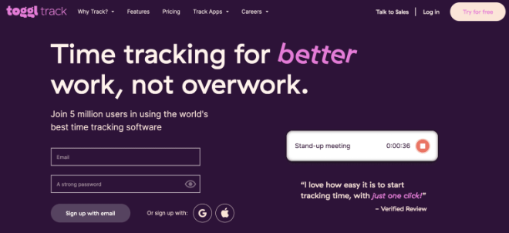

The free version of Toggl Track serves as an excellent entry point for individuals and small teams, offering basic time tracking capabilities. Users can seamlessly track their hours across devices, record project-specific time entries, and leverage both the mobile and desktop applications with automatic synchronization. (Connolly, 2022)

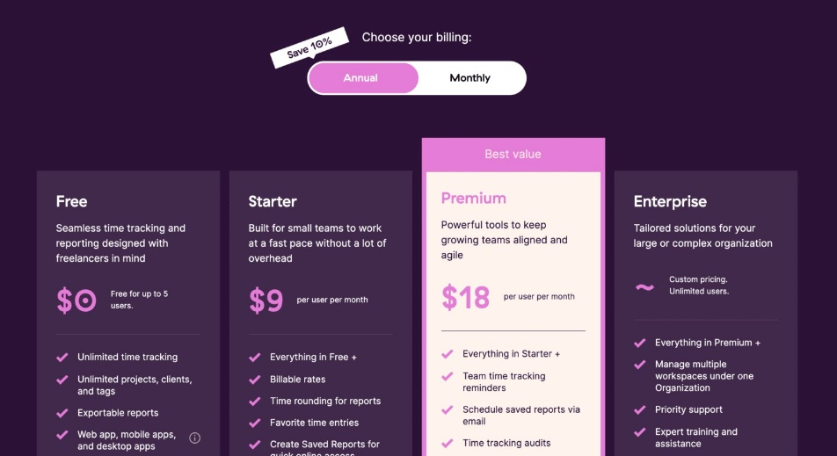

For those seeking additional features, Toggl Track offers paid plans with capabilities such as tracking billable rates and managing time for entire teams. Notably, Toggl Track is well-suited for enterprises, as it provides the flexibility to customize plans and pricing according to specific business needs. (Connolly, 2022)

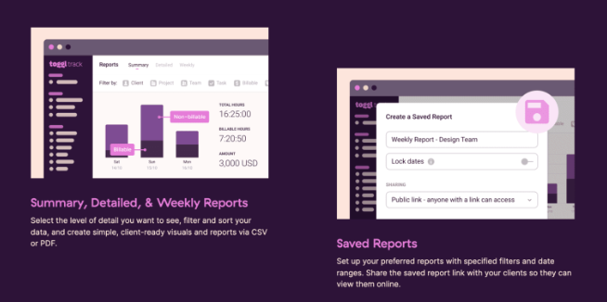

Different breakdowns of tracked time are displayed in summary reports. You can view information such as the number of hours your team worked on a given day or the amount of time allocated to various projects. In-depth analyses of tracked time can be found in detailed reports. You have the ability to modify time entries in Toggl Track's detailed reports. However, keep in mind that adding time for team members requires a Premium plan subscription. Weekly reports provide a concise overview of the time that your team monitored every week. You can use the export options for these reports to create CSV or PDF files, which is helpful if you use Toggl Track data to fill out timesheets. (Connolly, 2022)

Expand- /

|  |  |
| --- | --- |
| **Strengths** | **Weaknesses** |
| The Software User Friendly | Does not include proof-of-work and activity tracking functionalities |
| Comprehensive array of integrations | Lacks invoicing capabilities |
| Time Tracking Reminders | No Scheduling |
| Free Plan with basic features | UI lacks intuitiveness |
| Constant Reports | Paid plans are relatively costly in relation to the included features |

(Connolly, 2022)

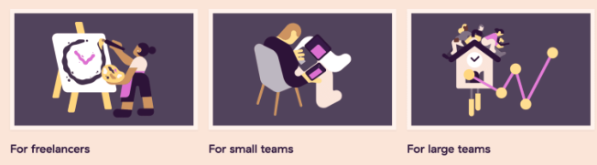

The Toggl Track user interface is simple to understand and operate. Since this app's primary function is to start and stop timers, it should be easy to use and straightforward. For lone users and small teams, the interface and design are excellent. Tracking time with the desktop application, mobile app, or browser extension is equally enjoyable for most users. The various app versions synchronise even when you switch devices. Toggl Track will detect and sync multiple devices if you set a timer on a mobile device while the desktop timer is still running. (Connolly, 2022)

**Overview of Clockify**

Clockify stands out as an exceptional time tracking software solution, offering robust features designed to assist both individuals and teams in managing their time effectively across projects and tasks. With a comprehensive set of functionalities, Clockify provides a versatile toolkit for timekeeping, reporting, and team management. (www.forbes.com, 2023)

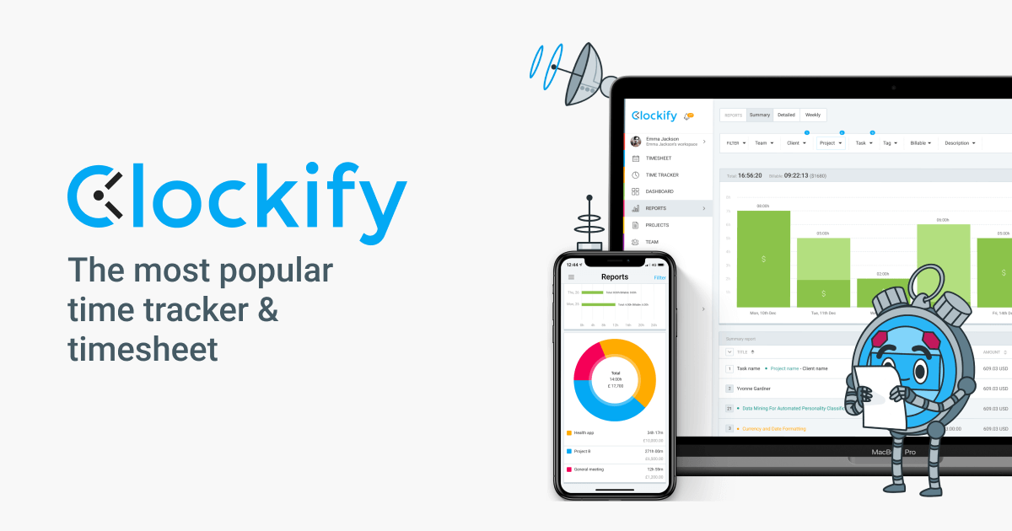

The timekeeping features in Clockify cover a wide spectrum, including essential elements like time tracking, timesheets, clock in/out kiosk, and a calendar interface. These features collectively empower users to meticulously record and monitor the time invested in various work-related activities. (www.forbes.com, 2023)

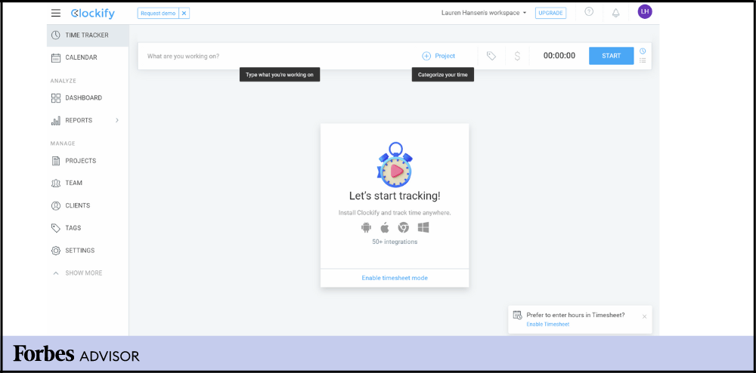

For comprehensive insights and analysis, Clockify's reporting features include dashboards, project progress and forecasting tools, reports, and activity tracking. These functionalities not only aid in real-time project monitoring but also contribute to strategic decision-making by providing valuable data on team performance and project timelines. (www.forbes.com, 2023)

Clockify goes beyond mere time tracking by incorporating management features such as time-off management, expense management, invoicing, and scheduling. This multifaceted approach ensures that users can not only track time but also efficiently manage associated aspects, streamlining administrative processes.

An attractive aspect of Clockify is its commitment to accessibility, offering a forever-free version. (www.forbes.com, 2023)

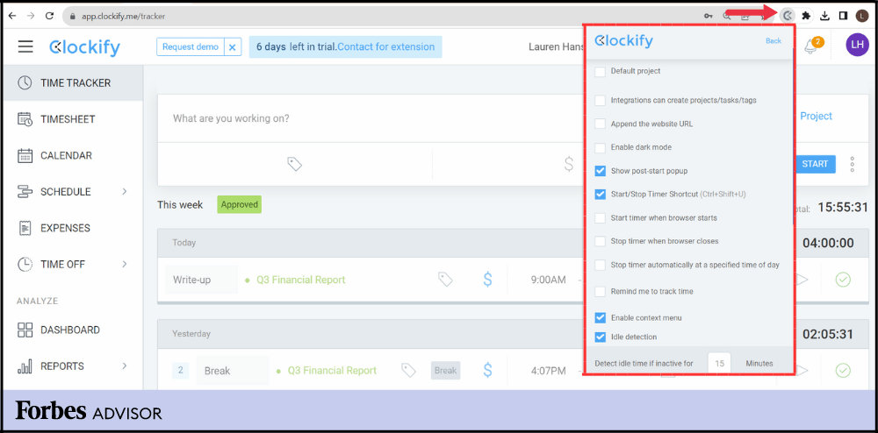

This feature makes Clockify a particularly budget-friendly choice for startups and small businesses with limited resources, allowing them to benefit from essential time management tools without incurring additional costs. (www.forbes.com, 2023)

Clockify operates seamlessly on both mobile devices and desktop computers, providing flexibility through browser apps, installed desktop apps, or browser extensions. Its user-friendly interface allows users to initiate timers or manually enter time via timesheets, fostering a straightforward and intuitive experience. The collapsible sidebar menu and customizable order of menu items further contribute to a user-centric interface. (www.forbes.com, 2023)

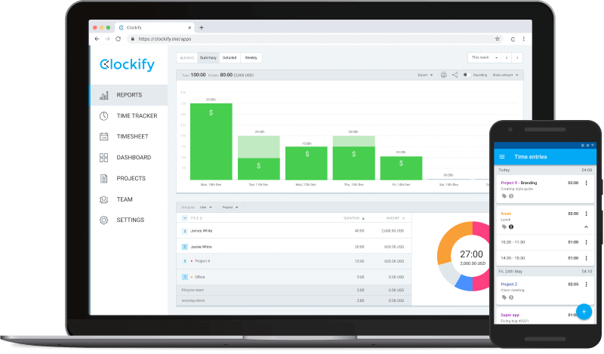

|  |  |
| --- | --- |
| **Strengths** | **Weaknesses** |
| Enjoy the Forever free version of Clockify at no cost. | Manually identify and rectify time entry errors. |
| Try PRO features free for seven days, no card needed. | Manually export data to payroll software. |
| Unlimited users, no restrictions. | Pricing for the Kiosk feature can be unclear. |
| Access diverse features in the free version. | The usability of the Kiosk feature can be challenging. |
| Clear and straightforward pricing with Clockify. |  |

(www.forbes.com, 2023)

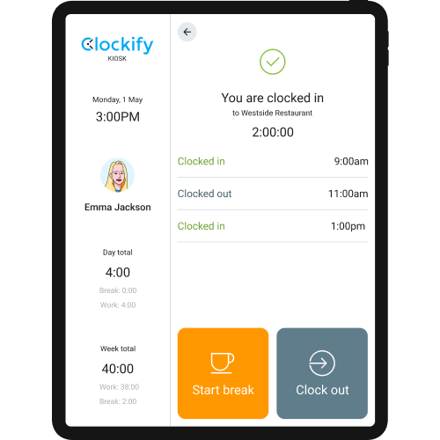

Top Features

**Offline Time Tracking**

Clockify ensures seamless time tracking even in offline scenarios, allowing users to continue tracking time without interruption if they temporarily lose Wi-Fi or data connectivity. The system intelligently syncs the offline time data with the rest of the platform once an internet connection is reestablished. (www.forbes.com, 2023)

**Idle Detection**

The idle detection feature, accessible through the browser extension, enhances accuracy by recognizing periods of inactivity. If the user is away from their computer for a specified duration, Clockify sends a message upon their return. (www.forbes.com, 2023)

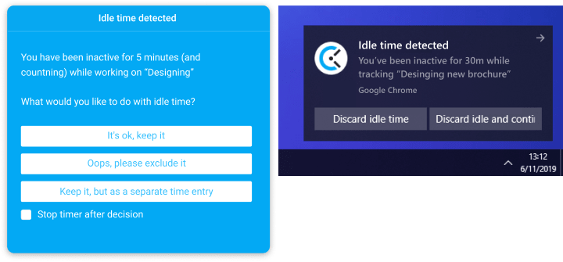

**Auto Tracker**

Clockify's Auto Tracker feature, once activated, automatically monitors and records the time spent on various applications. This is particularly useful for users who engage with multiple apps simultaneously during their workday, providing an effortless way to account for all activities. (www.forbes.com, 2023)

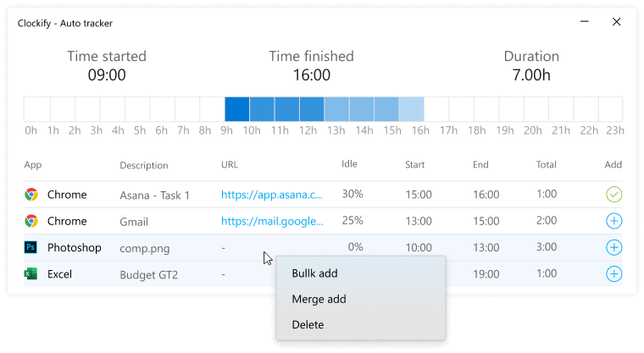

**Timesheets**

The Timesheets feature seamlessly integrates with the Timer function, automatically populating time entries. Alternatively, users have the flexibility to manually input hours into the timesheet without relying on the timer. (www.forbes.com, 2023)

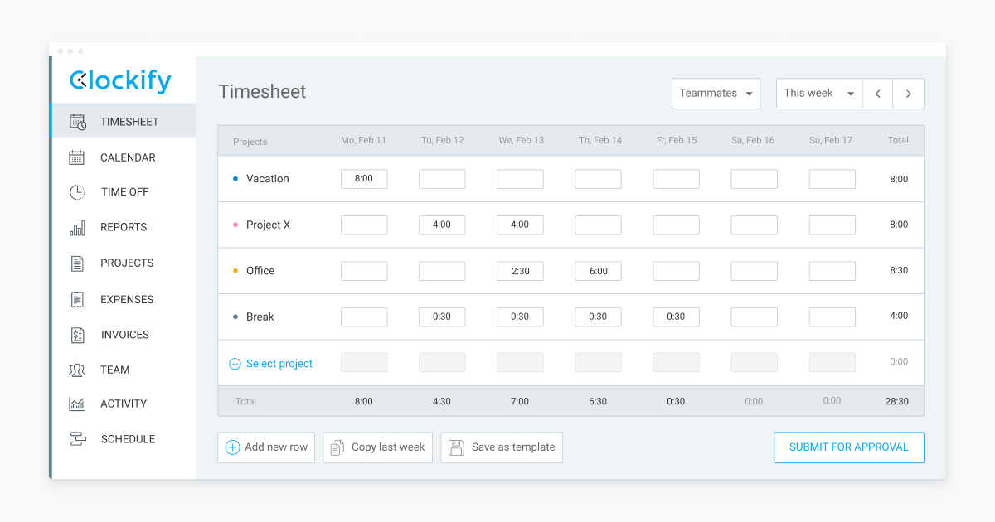

**Overview of Timely**

Works with **(Web, macOS, Windows, iOS, Android, Chrome, Firefox)**

The most effective time tracking applications strive to make the process of accurately recording your time spent as simple as possible. An automated time tracker is the most accurate and painless option available (Timely, 2024).   
  
Memory AS's Timely is a time-tracking tool that creates "Memories" of all the websites and applications you use throughout the day (Timely, 2024).

1. Automatic time tracking:

* Timely tracks time spent on tasks and activities in the background by using automatic time tracking technologies. This guarantees precise tracking without interfering with productivity and does away with the need for manual time entering (Timely, 2024).
* Using information from users' digital activities—such as the programmes they use, the websites they visit, and the documents they open—the application intelligently classifies time entries.

1. Calendar integration:

* Popular calendar programmes like Google Calendar, Outlook, and Apple Calendar are all easily integrated with Timely (Timely, 2024). It allows users to easily track time against calendar entries by syncing their scheduled events and appointments (Timely, 2024).
* When users integrate their calendars, it gives them a comprehensive picture of their schedule and makes it easier for them to match their time tracking to scheduled tasks and obligations.

1. Project and Task Management:

* Users may easily track the amount of time spent on particular tasks by using Timely to organise their work into projects and tasks (Timely, 2024). Within the application, users may assign tasks, establish projects, and set deadlines.
* Users of the application can track time by project, client, team member, or task type, giving them flexibility in project management.

1. Real-time collaboration:

* Timely facilitates seamless project sharing, work delegation, and team management capabilities by supporting real-time collaboration (timely, 2024).
* To facilitate collaboration and enhance teamwork, users can track team productivity, provide permissions and access levels to team members, and interact within the application (Timely, 2024).

1. Reporting and analytics:

* With Timely's powerful reporting and analytics features, customers can create comprehensive reports on team productivity, project advancement, time tracking, and more.
* The analytics dashboard of the programme provides users with insights and visualizations of their time usage habits, enabling them to spot inefficiencies, streamline processes, and make data-driven choices (Timely, 2024).

1. Privacy and Security:

* Timely employs industry-standard encryption and security protocols to safeguard sensitive data, placing a high priority on user privacy and data protection.
* Users can tailor access permissions for stakeholders, clients, and team members and manage their data privacy settings (Timely, 2024).

1. Cross-Platform Compatibility:

* Timely is compatible with a number of operating systems and platforms, such as mobile (Android and iOS), desktop (Windows and macOS), and web browsers.
* Users may maintain workflow continuity and convenience by easily switching between devices and accessing their time-tracking data from any location (Timely, 2024).

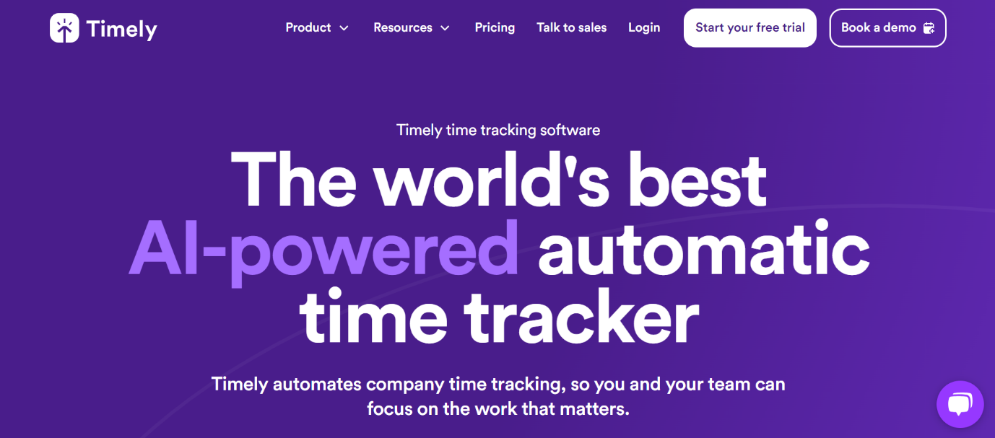

Homepage:

Using timers to start and stop for certain actions, users may track time right from the dashboard. Users can track their progress throughout the day by using the dashboard, which gives real-time feedback on the amount of time spent on each job.

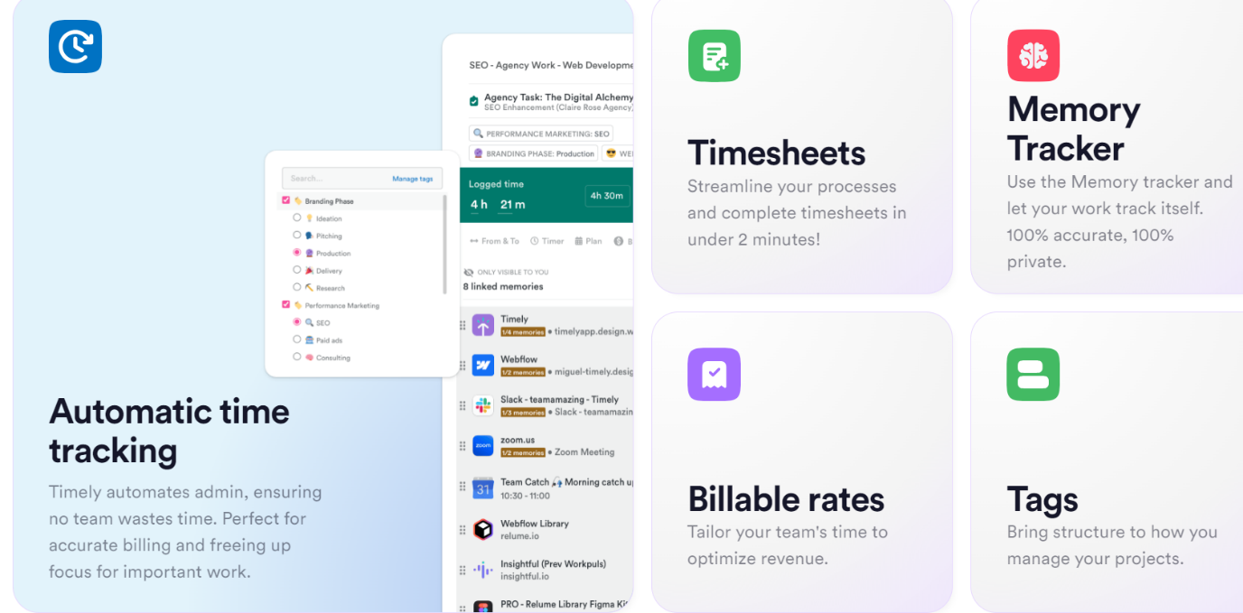

Other tools:

Users can obtain reports and statistics on their time tracking data through the dashboard. In addition to analysing productivity trends and patterns across time, users can generate reports on the amount of time spent on various projects, clients, or tasks.

**Strengths and Weaknesses:**

|  |  |  |
| --- | --- | --- |
| **Name of application** | **Strengths** | **Weaknesses** |
| Timely | Advanced Reporting and Analytics: Timely gives users access to powerful reporting and analytics capabilities that let them create comprehensive reports and discover patterns and trends in productivity. | Learning Curve for New Users: For people who are not used with manual time entering techniques, the automatic time tracking tool may take some getting used to. |

**Infographic Comparison**

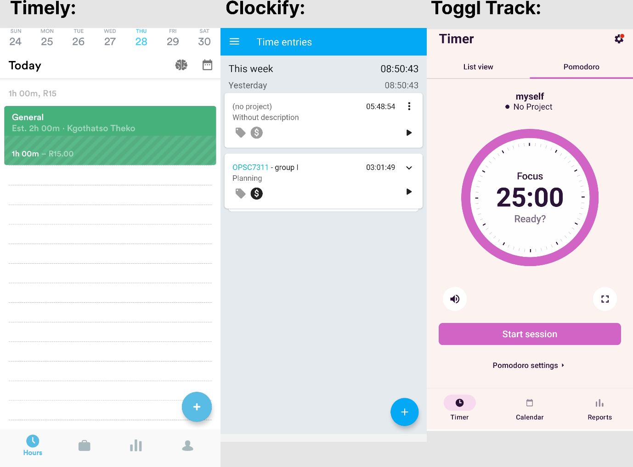

**Innovative features:**

Drawing from an analysis of three employee time tracking apps—Clockify, Toggl Track, and Timely —several essential features have been identified that would be advantageous to incorporate into our own app:

Clockify Design Structure and Layout: The user experience and ease of navigation are improved by Clockify’s clever design structure and layout. Similar design principles can be incorporated into our app to enhance usability and user satisfaction in general.

Timesheet Management (from Clockify): Clockify provides users with an extensive range of timesheet management features that enable them to effectively monitor the amount of time they spend on tasks and projects. Our app could benefit from having comparable timesheet management features to help employees track and report their time accurately.

Time Off Management (from Clockify): Clockify streamlines the process for both supervisors and employees by offering features for managing time off requests and approvals. Our app's time off management features can improve organisational effectiveness and make managing leaves easier.

Chart Display (from Clockify): You can visualise time tracking data, including project breakdowns and productivity trends, with Clockify's chart display options. By adding comparable chart display features to our app, users will be able to more readily extract insights from their time tracking data.

Offline Time Management (with Clockify): Clockify has offline time tracking capabilities that let users log their working hours even when they're not online. Our app's offline time management features can guarantee that work hours are continuously tracked even in the event of a connectivity problem.

Gamification Elements:(Clockify) Drawing inspiration from gamification principles, we can introduce features such as achievement badges, levels, and rewards for users who consistently track their time, meet deadlines, or achieve productivity milestones. By gamifying the time tracking process, we can make it more enjoyable and encourage healthy competition among employees to boost productivity.

|  |  |
| --- | --- |
| **Name of application** | **Innovative features** |
| **Toggl Track** | Pomodoro Timer Integration: Toggl Track integrates with Pomodoro timer methods, enabling users to divide work into concentrated bursts for better time management and productivity (Toggel Track, 2024). |
| **Timely** | Timely uses Memory AI technology to automatically record and classify the amount of time spent on different jobs and activities (Timely, 2024). |

**Conclusion**

The optimal option among these programmes ultimately comes down to personal preferences for workflow, individual needs, and the features that best support users' productivity objectives. Our development research concludes that we can develop a complete and user-friendly time tracking and management solution that satisfies employee needs and boosts productivity within the company by combining the greatest features from Clockify, Toggl Track, and Timely into our… ‘Phase Tracer’.

**Reference List**

Connolly, A. (2022). *Toggl Track Review 2022*. [online] Hubstaff Blog. Available at: <https://hubstaff.com/blog/toggl-track-review/>

FREE Employee Time Tracking Software [That Doesn’t Suck] | Toggl Track. [online] Available at: <https://toggl.com/track/employee-timetracking/>.

support.toggl.com. (n.d.). *What is Toggl Track?* [online] Available at: <https://support.toggl.com/en/articles/2220404-what-is-toggl-track>.

timelyapp.com. (n.d.). *Timely - Time Tracking Software*. [online] Available at: <https://timelyapp.com/>.

www.forbes.com. (n.d.). *Clockify Review 2023: Features, Pros And Cons – Forbes Advisor*. [online] Available at: <https://www.forbes.com/advisor/business/software/clockify-review/>.